

**LAB NO-1**

**CISCO INSTALLATION:**

Cisco is a software contain computing devices that illustrate how to communicate the one network to another.

**Installing Process:**

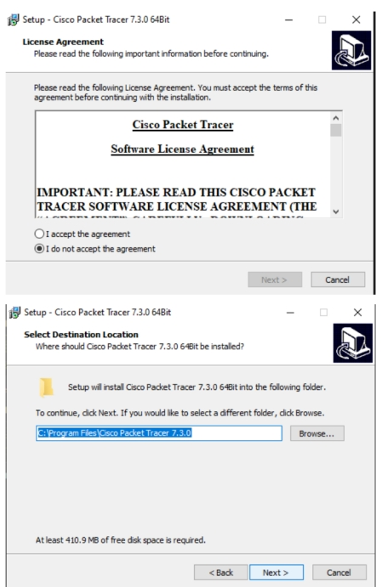

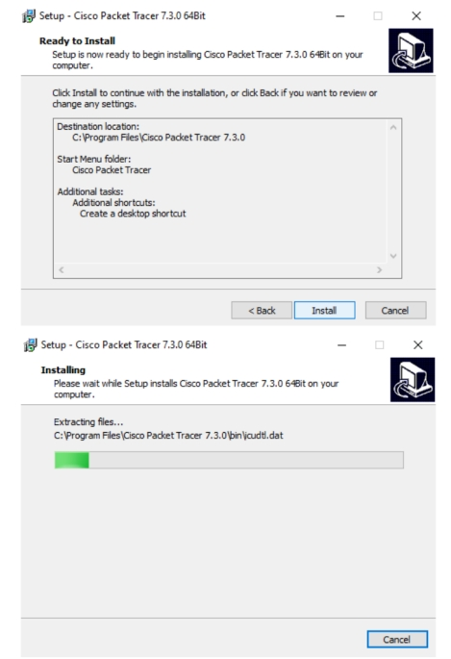

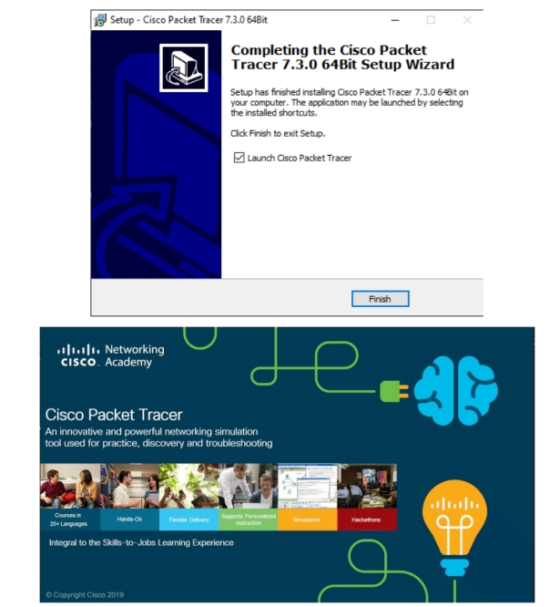

**LAB NO-2**

**P2P:**

**P2P:**

The word P2P is the abbreviation of peer to peer in which we connect two computer or pc directly without connect another device.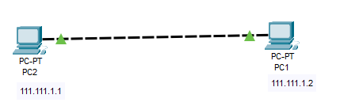

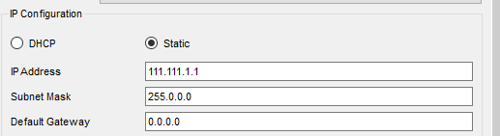

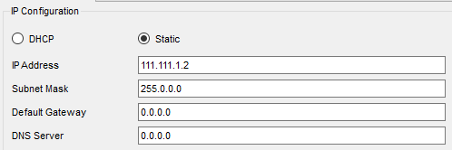

**Explanation:**

In this lab we connect two pc directly with a wire and give a IP address for both pc of class A. The IP address is a unique identify of any pc or any user.

**Output:**

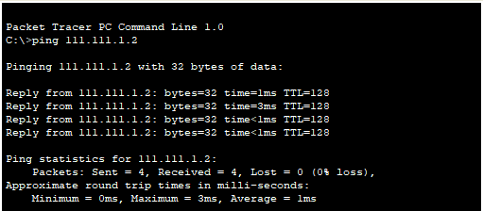

**Explanation**

In this we use a ping command. Ping command is use to communicate the two pc. After the ping command we dial the IP address of the second pc which we want to communicate. In the output section we see that the lost is 0, so the data we send from first pc to another pc is transfer without any lose.

**LAB NO-3**

**SWITCH-CONFIGURATION:**

**Switch configuration:**

Switch configuration is a method in which we connect a two or more pc with the help of switch. Switch do a work as a communication layer which communicate the pc with each other.

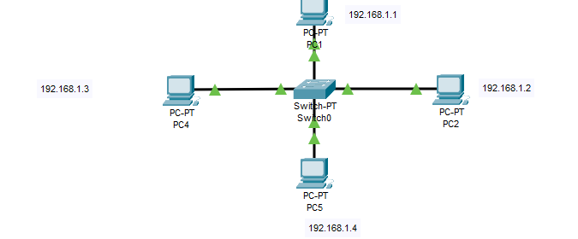

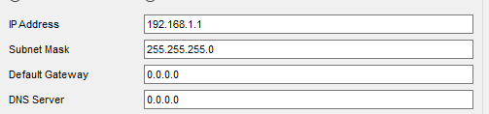

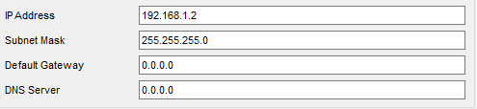

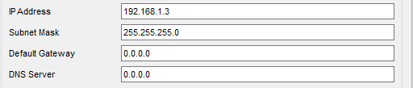

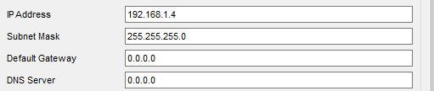

**Explanation**

In this pc we connect a four pc with a switch and giving it to same IP address of class C. The switch is used to connect the pc of same class.

**Output:**

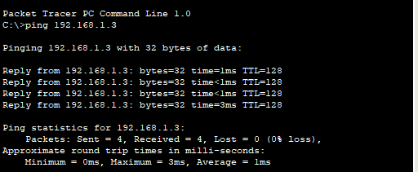

**Explanation**

In the output section we ping a first pc to the third pc. The first pc is does not connect directly with the third pc. The connection is successful with the help of switch and the data which we send from first pc is reached at third pc without any lose.

**LAB NO-4**

**ROUTER-CONFIGURATION:**

**Router configuration:**

Router configuration is a method in which we use a router to communicate the one pc to another pc. In this method we use a router to transfer resources from one pc to another pc of different network.

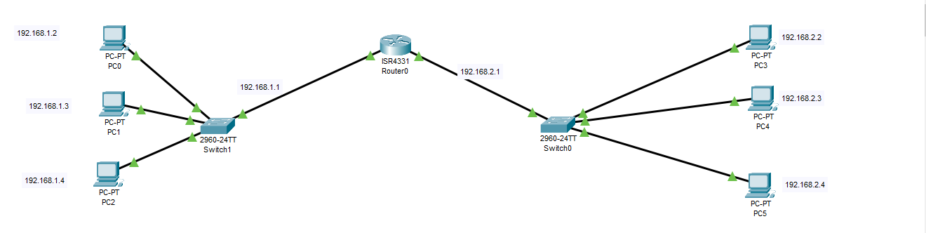

Switch1:

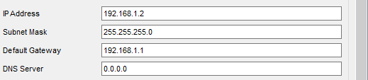

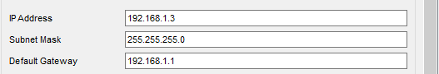

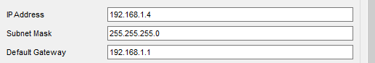

Switch2:

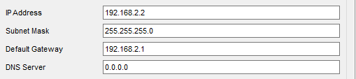

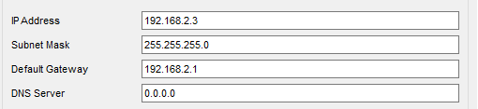

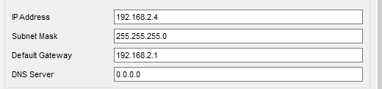

**Explanation**

In this lab we connect a three pc of same IP address to the first switch and connect a three pc of same IP address to the second switch. So the switches are different IP address with respect to each other. By connecting the two switch we use a router which communicate the different IP address of pcs. We set a default gateway address to the pc which is come from router which discuss below.

**Code Explanation:**

**Enable**: it is use to enable the router to work.

**Config t**: it is use to configuration.

**int**: it is use to allocate the palace of router i-e g0/0/0, g0/0/1

**ip add**: it is use to set the default gateway of the path to which the message or resource will send. After the ip add we add the subnet mark i-e 255.255.255.0.

**no shut**: it is use to wake the router. By default, the router is sleeping we want to wake up it.

**End**: it is use to end the program or command.

**Output:**

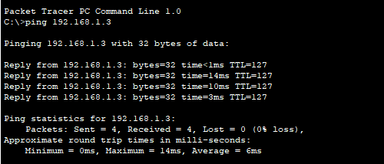

**LAB NO-5**

**TELNET-CONFIGURATION:**

**Telnet-configuration:**

Telnet is a protocol that is used for remote login from one computer to another on same network. It works on port 23.

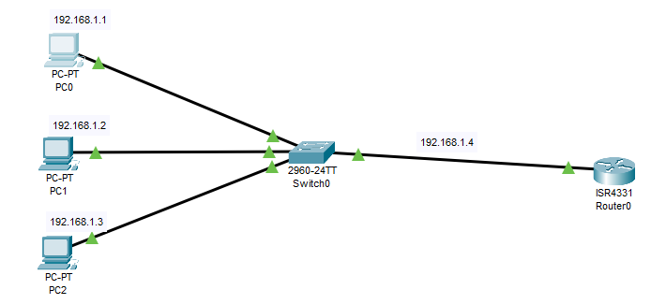

**Explanation**

In the above design I have connected three PC’S and assign them IP of class c with same network. These PC’S are connected to a switch which also connected to a router.

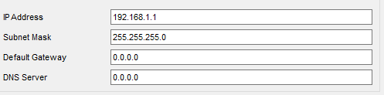

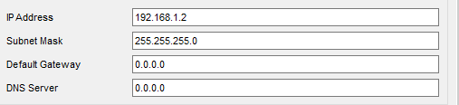

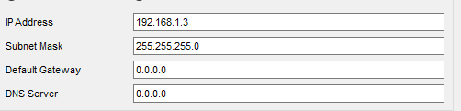

**Explanation**

After connecting the PC, we assign an IP address of class c. Then we set a default gateway where the message is sent to one pc to another.

**Code Explanation:**

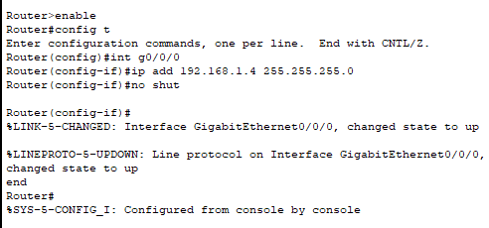

**Explanation**

**Enable**: it is use to enable the router to work.

**Config t**: it is use to configuration.

**int**: it is use to allocate the palace of router i-e g0/0/0, g0/0/1

**ip add**: it is use to set the default gateway of the path to which the message or resource will send. After the ip add we add the subnet mark i-e 255.255.255.0.

**no shut**: it is use to wake the router. By default, the router is sleeping we want to wake up it.

**End**: it is use to end the program or command.

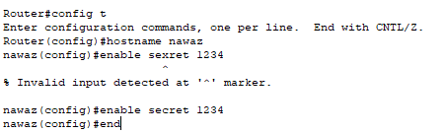

**Explanation**

**Config t:** It is use for configuration.

**Hostname:** It is use to change the hostname of a router.

**Enable secret:** It is use to set the password of router.

**Exit:** It is use to end the program or command.

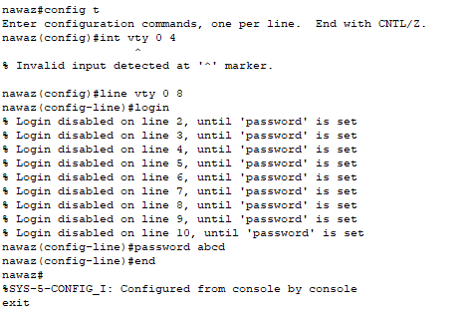

**Explanation**

**Int vty 0 4:** This command is used to specify the range of user.

**Login:** This command is used to login the user into the telnet.

**Password:** This command is used to set the password of the telnet.

**Exit:** This command is used to exit the command or program.

**Output:**

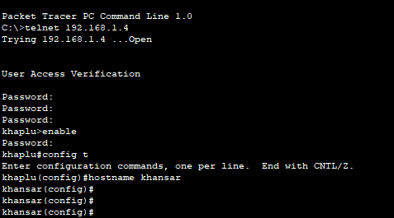

**Explanation**

**telnet 192.168.1.4:** Here i try to access my router from remote area pc by using the telnet protocol.192.168.1.4 is my default gateway or router IP.

**Password:** It is the password of the telnet. The password is not seen but work.

**Enable:** This command is used to enable the router.

**Password:** It is the password of the router which we set in the CLI of router.

**Now I fully access to my router and I change my router hostname or password.**

**LAB NO-6**

**DHCP-CONFIGURATION:**

**DHCP-configuration:**

The word DHCP mean it is a protocol that is used to set the dynamic IP to the pcs.

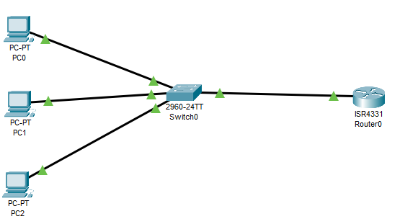

**Explanation**

In the above diagram we connect a three pc to the switch and connect the switch to the router. We do not set the IP of the pc because we want to set the IP by default. We set the static IP of the whole pc to default IP.

**Code Explanation:**

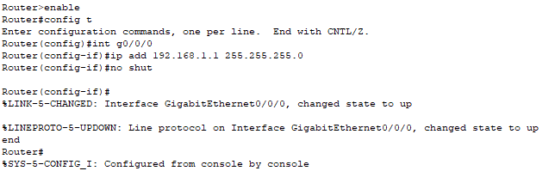

**Enable**: it is use to enable the router to work.

**Config t**: it is use to configuration.

**int**: it is use to allocate the palace of router i-e g0/0/0

**ip add**: it is use to set the default gateway of the path to which the message or resource will send. After the ip add we add the subnet mark of the router IP i-e 255.255.255.0.

**no shut**: it is use to wake the router. By default, the router is sleeping we want to wake up it.

**End**: it is use to end the program or command.

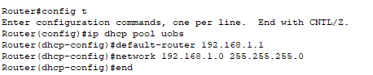

**IP dhcp pool:** To set the name of pool.

**Default-router:** IP of the default gateway

**Network:** Write the network and subnet component of the IP.

**End:** End the configuration mode.

**Output:**

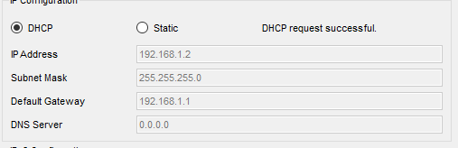

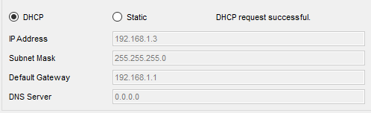

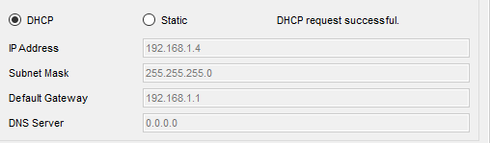

**Explanation**

In the output section we see that the three pc got an IP address. This IP address is given by default by using the router IP. So we can easily communicate the pcs by using this default IP.

**LAB NO-7**

**VLAN-CONFIGURATION:**

**VLAN-configuration:**

VLAN is the logical group of devices in same network which improve traffic management or security. In VLAN we make a different network for both side of switch.

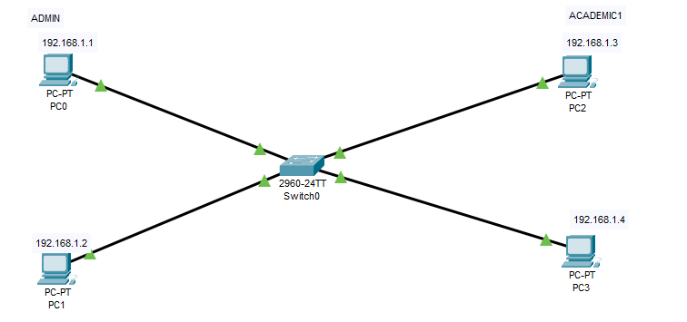

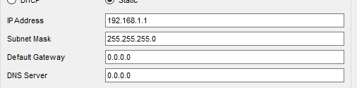

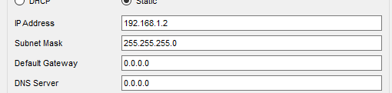

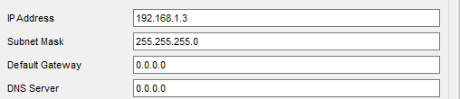

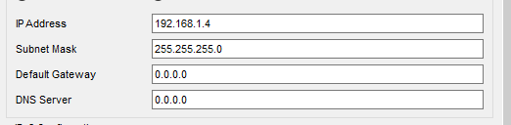

**Explanation**

In the above diagram we connect a four pc to a switch and set them IP address of same class c. We make a two group, first group is admin and the second group is academic1. By using the VLAN concept we make the two group with different network so we cannot connect the one group to another.

NOTE:

We have the first two pc in the admin group and the other two pc are in the academic1 group.

**Code Explanation:**

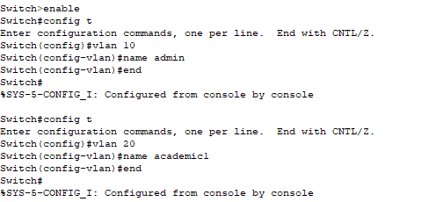

**Enable**: it is use to enable the router to work.

**Config t**: it is use to configuration.

**VLAN:** VLAN name or digit

**Name:** To set the name

We set the VLAN different for the two group so we can understand it.

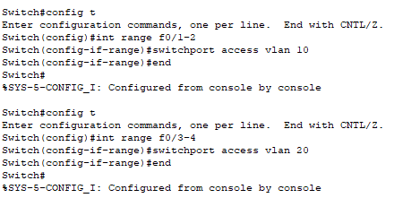

**Config t**: For configuration

**Int range**: To set the range of group.

**Switch port access VLAN**: To access the VLAN number of the group which we set in the above code.

**Output:**

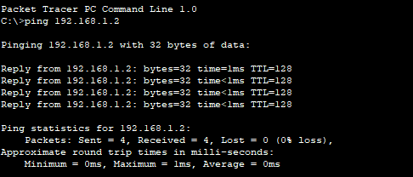

**Explanation**

In this output section we ping a first pc to the second pc in the same group. We see that the connection is established and when we send the data to the second pc the lost is 0 i-e the data is received by the receiver without any lose.

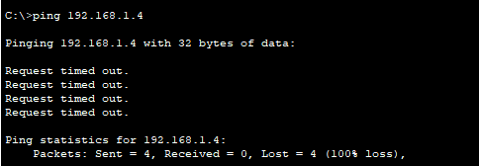

**Explanation**

In this output section we want to communicate the first pc to the fourth pc in different group. We see when we send data from first pc to the fourth pc the lost percentage is 100. So we can say that the connection is does not established in this two group. It is the benefit of using VLAN that we make a two different network in the same class without using router.